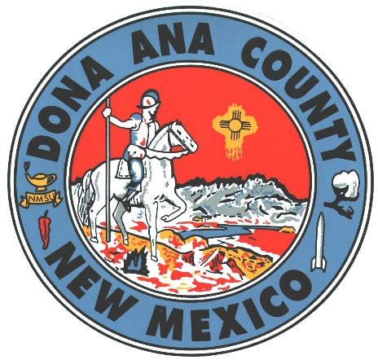
Inventory Accountability – Fire Administration

Past audits have indicated a pattern of inconsistencies in inventory accountability procedures throughout Doña Ana County. Thus, a recent influx of Fire Trucks and Equipment prompted the internal auditor to reach out to the Fire Administration to discuss their inventory procedures. A discussion with the Deputy Fire Chief resulted in an agreement to allow for meetings with the Lieutenants who lead the daily activities of the three full-time fire stations within Doña Ana County, to review their current inventory procedures. The Deputy Fire Chief welcomed an assessment of current inventory procedures to ensure that the Fire Administration was adequately accounting for its assets. Any improvement areas could thereafter be addressed and then passed along to volunteer-operated fire stations as applicable.
NOTE - Fire Administration comments are set in italics.
The Deputy Fire Chief escorted the internal auditor when meeting with the Lieutenants of Fire Stations #1, #2, and #9. At each fire station, the internal auditor inquired about 1) ordering and receiving procedures, 2) the addressing of damaged, obsolete, and untagged inventory, 3) the inspection of fire extinguishers, 4) asset security, and 5) inventory accountability procedures for fixed assets and sensitive items. After inquiring about these areas, the internal auditor performed a sample inventory of fixed assets and sensitive items, and checked fire extinguisher tags for monthly updates.
Inquiries & Observations
- The Audit revealed that inventory is ordered after fire stations correspond with the Fire Administration, as the Fire Chief (or his designee) signs off on submitted requisitions. Inventory is received by and tagged at the warehouse (Fire Administration is notified when it arrives) or by Fleet (vehicles). Thus, the flow of inventory to the fire stations via the Fire Administration allows for the supervisory oversight of ordering and receiving procedures. It is incumbent upon individual fire station leadership to review the contents of packaged items, and report any missing, damaged, defective, or incorrectly ordered items to the Fire Administration for corrective actions. Per Fire Administration, the current ordering process is an improvement.
In years past, the volunteer station chiefs would enter their own requisitions and work directly with the warehouse to receive their own orders/equipment. By centralizing the ordering and approval process, it now ensures the following:
- Equipment is standardized countywide
- Property/asset tags are placed on the equipment and the Asset forms are submitted for entry.
- By identifying that multiple stations are in need of the same equipment, the ability to purchase in bulk equates to cost savings, which in turn translates to fiscal responsibility.
- The internal auditor was told that when obsolete inventory is discovered, the proper documentation is filled out in the Emergency Response System (ERS) so that Fire Administration can take adequate steps to remove the obsolete inventory. For damaged inventory, a digital work order is submitted. Finally, inventory tags are requested by Fire Administration to address untagged inventory.
The Lieutenants have been assigned to visit the fire stations in order to conduct inventory inspections. The LTs were instructed to identify the equipment in need of property tags, and begin the process for placing a tag and completing the asset paperwork for submission. The [Fire Administration is] utilizing the new “Asset Panda” platform introduced by the IT Dept.
- Fire extinguisher inspections – The Audit notes that fire extinguisher tags on fire extinguishers at Fire Stations #2 & #9 did NOT indicate any monthly inspections; fire extinguishers at Fire Station #1 indicated an inspection only for September 2022.
The Lieutenants and volunteer chiefs at all of the stations were reminded of the importance of inspecting the extinguishers at every station on a monthly basis. This directive or message was shared during both the staff meeting and monthly officers meeting held via WebEx.
- Inventory Security – Upon inquiry of fire station access, the internal auditor was told that volunteer fire stations change access codes monthly. When no one is on-hand, fire stations are locked. As for items that may require special safeguards, the internal auditor was informed that pharmaceuticals are locked up and accounted for closely, as the person who is issued the items is personally responsible for their accountability.
Fire Administration continues to work towards 100% of the fires stations to be equipped with card reader access and cameras. This will ensure that accessibility is not hindered when a door code is changed. When dealing with the separation of volunteer or paid personnel, their county issued access card will be turned off.
As for the pharmaceutical side, EMT’s fall under direct written protocol from both the State and local medical direction. Pharmaceutical supplies are replaced post field use or when expiration of medication is reached. Inventory logs are kept at fire administration in the pharmacy closet and are subject to random quarterly inspections by both the state pharmacy board, and the contracted pharmacist.

While fire stations have cipher locks in place, not all of them are functional. In addition, not all fire stations have functional card readers. Fire stations are still awaiting a back order of cameras as an additional security measure.
As previously mentioned, fire administration continues to work towards the installation of cameras and card readers at every fire station. Since the recent audit conducted by the internal auditor, card readers at stations 1, 6, 9, and 11 have been activated and placed in service by the DAC IT Dept.

- Inventory procedures – Lieutenants conduct the actual inventory on an annual basis. As drivers conduct daily inventories, any missing items are reported to the Lieutenant on-duty, who ensures that the Lieutenant on the next shift is made aware of this. Also, a notification is made in the ERS. When it comes to adjusting the number of assets available (for annual inventories), only the Lieutenants and Fire Administration may make the physical-to-book inventory adjustment.
The emergency reporting (ERS) platform will allow stations to immediately identify in the system, when equipment is relocated, taken out of service for repair or maintenance or replaced with new equipment. The ERS platform aids in tracking equipment from the time it is received to the time that it is removed or placed out of service and discarded.
Below is are the results of an inspection from the annual state Fire Marshall’s report - March ‘22.
Fire Station | Number of Violations | Status
Anthony Fire Department | 1 | Not Corrected
Chaparral Fire Department | 1 | Not Corrected
Doña Ana Fire Department | 8 | Not Corrected
Doña Ana Fire Administration | 2
Fairacres Fire Department | 4 | Not Corrected
East Mesa Fire Department | 5 | Not Corrected
Garfield Fire Department | 6 | Not Corrected
La Talavera Fire Department | 5 | Not Corrected
Mesquite Fire Department | 2 | Not Corrected
Las Alturas Fire Department | 3 | Not Corrected
Organ Fire Department | 1 | Not Corrected
Santa Teresa Fire Department | 2 | Not Corrected
Santa Teresa Station 2 Fire Department | 1 | Not Corrected
Rincon Fire Department | 1 | Not Corrected
Dona Ana County Fire Rescue has completed or addressed the deficiencies discovered during the last visit by the representatives of the State of NM FMO by purchasing and installing several pieces of equipment.
- Purchase and installation of 10’ sections of hard suction on brush units at stations 1, 4, 5, & 12
- Purchase and installation of traffic cones on various apparatus as identified during the inspection/visit
- Purchase and installation of 3 fire extinguishers
- Purchase and installation of one fire extinguisher bracket
- Installation of traffic safety vests
- Installation of the flashlights on two units as identified during the inspection/visit
- Purchase and placement of new up to date Automated External Defibrillators (ongoing project)
Pictures and updates were provided to the NM State FMO representatives as the projects were completed, in order to obtain a satisfactory acknowledgement as required in order to close out the inspection process.
Results & Recommendations
The internal auditor specifically inquired about the FY22 inventory and the use of Asset Panda. The Deputy Fire Chief explained that the normal inventory for FY22 had been completed; however, the Fire Administration is awaiting the Asset Accountant’s review of updated inventory accounts, which separates Fire Administration inventory into North and South Districts. Combining such large amounts of assets would result in submitting two, huge inventory listings.
Station 3 on the NMSU Campus and Station 14 in Santa Teresa were also included in this effort to migrate from the old county tracking system to the newly introduced Asset Panda platform.
The ERS that the Fire Administration currently uses already meets state and federal requirements, while Asset Panda is purported by the County. Although there are differences between the two systems, the Fire Administration seeks a means to integrate data between them, avoiding the need to record inventory manually into two different digital records.
The overall goal or vision for DACFR is to streamline accountability of equipment, while enhancing the identification of equipment requiring regular maintenance or service.
In addition, to deal with the excessive amount of inventory within the administration, the Fire Administration seeks an Inventory Technician (full-time) position. This person’s main duty would be full-time inventory accountability of all Fire Administration assets, scheduling routine maintenance of response equipment, [and] exchange of “out of service” equipment with equipment that is ready for use.
Per the chart below, the Audit –
- Noted the total number of assets recorded on the most recent inventory listings
- Traced a sample of assets from the inventory listings to the floor (actual location)
- Traced a sample of assets from the floor (actual location) to the inventory listing
- Noted unaccounted-for assets found on the floor, as well as untagged inventory
Items have since been placed on the inventory and tagged as necessary.

 | Fire Station 1 | Fire Station 2 | Fire Station 9
Total Assets | 93 | 36 | 53
Listing to Floor | 10 | 3 | 14
Floor to Listing | 1 | 1 | 8
Missing Tag | 17 | 16 | 16
Not Listed | 8 | 5 | 2
Missing Items | 6
The Audit notes that Fire Station #1 had taken the initiative to note inventory found on current and past inventory listings that were no longer present, which indicated six missing items.
The Audit notes that Fire Station #9 had stockpiles of obsolete inventory that lined the entirety of one wall in its second fire station; the items appear to have been there for a while.
- Recommendation: Appropriate procedures should be taken to remove the missing inventory items from the inventory list for Fire Station #1.
- Recommendation: Fire Station #9 leadership should take the necessary steps to record and remove obsolete inventory noted in the photos below.
- Recommendation: Untagged items should be tagged per the Capital Outlay SOP.
- Recommendation: Unaccounted-for items should be added to the inventory listing and tagged. In process
- Recommendation: For fire stations that do not have cameras, have missing or nonfunctioning card readers, and missing or nonfunctioning cipher locks, leadership should remain diligent in following up to get the items operational as each fire station houses hundreds of thousands of dollars’ worth of equipment. Ongoing
- Recommendation: While taking inventory appears to be a straightforward practice of printing lists and marking the items found, the Audit encourages Fire Administration to write down its procedures to bring uniformity and add best practices as applicable.
- Recommendation: As a safety measure, Leadership at all fire stations should ensure that monthly fire extinguisher checks are conducted and indicated on fire extinguisher tags.
- Recommendation: While the details of the State Fire Marshall’s annual inspection were beyond the scope of this Review, the noted violations should be addressed as soon as possible to bring each station into full compliance. This expectation will continue to be mentioned during every staff or officer meeting countywide.
SOPs & Best Practices
The National Fire Protection Association (NFPA) has a guide to fire extinguisher inspection, testing, and maintenance.
Qualifications
You are not required to be certified in order to perform an inspection; any knowledgeable, competent person should be able to do it.
Frequency
NFPA 10 requires extinguishers be inspected when they are initially installed and once a month after that. You should inspect extinguishers more frequently if they are installed in locations where they are more prone to rust, impact or tampering.
Recordkeeping
Records of the monthly inspections need to be maintained by either putting a tag or label on the extinguisher or by having it recorded on paper or electronic files. The following items need to be recorded:
- The month and year of the inspection
- The person conducting the inspection
These records need to be maintained for at least 12 months.
Capital Outlay (Fixed Assets) SOP:
2.2 Property Identification (Asset Tagging)
Tagging is important for providing an accurate method of identifying individual assets, facilitating the inventory process on a periodic basis, and controlling the location of capital assets.
While the SOP goes on to identify the Warehouse Technician as the person tagging assets, the Audit purports that it is incumbent upon each department, office, and section to ensure that their assets are properly tagged.
2.18 Disposal of Capital Assets
Disposal of capital assets shall be in accordance with all federal, state, and local laws and regulations governing the disposition of county real and personal property.
Damaged or obsolete assets should be reported to the Financial Services Director when transferred to the Facilities and Parks department to be stored in a storage area to await disposition.
2.19 Sensitive Items
Sensitive Items below the capitalization threshold of $5,000.00 shall be tagged, inventoried, and safeguarded at the Using Department level. Ongoing
NOTE: The Audit supports Fire Administration plans to use cameras and card readers as a means of both controlling and monitoring fire station access.
Fire Station 9 - Stockpiles of Obsolete/Unused Inventory- The process for properly recording and disposing of this unused or outdated equipment has been initiated by the personnel assigned to station 9.
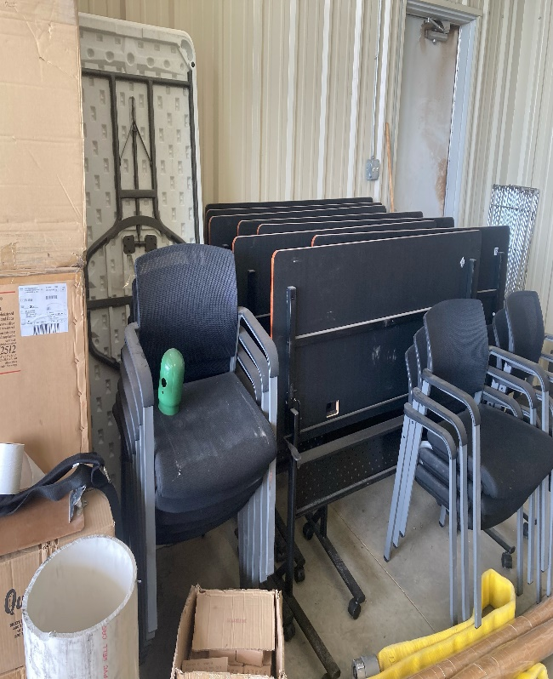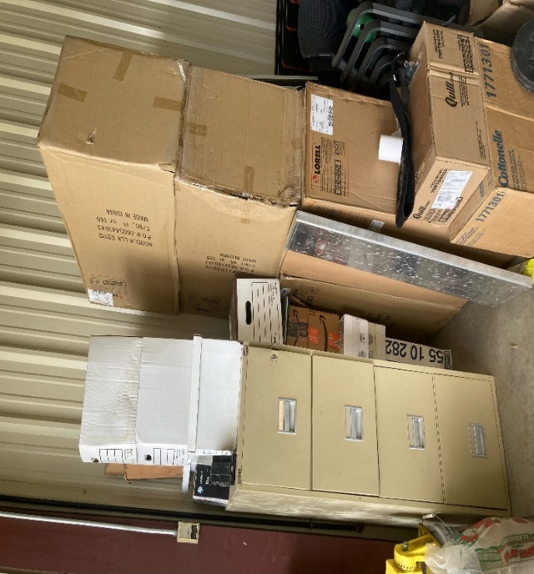
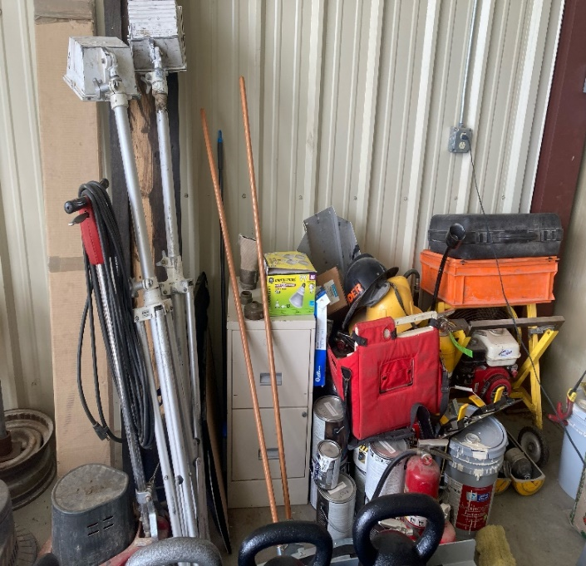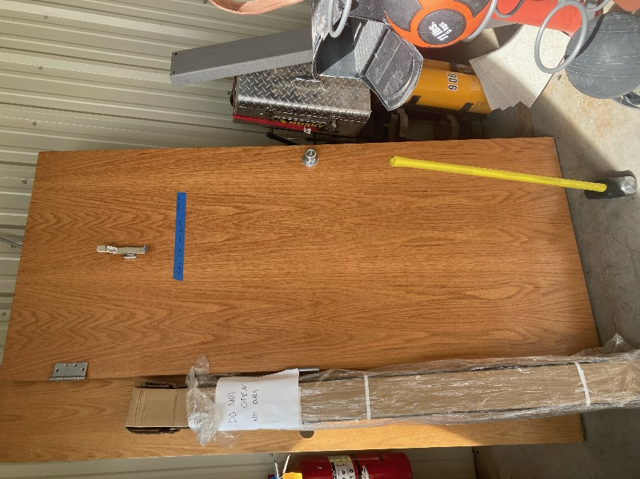
The internal auditor acknowledges and thanks Fire Administration Leadership for its professionalism and courtesy during this review of inventory procedures. Fire Administration is committed to working with all the DAC departments to ensure that transparency and accountability is at the forefront of [the] organization.

